DATA ANALYSIS & VISUALIZATION ON MICROSOFT STOCK

IMPORT MODULE
import numpy as np
import pandas as pd
import matplotlib.pyplot as plt
import seaborn as sns

READ CSV FILE
ms=pd.read_csv('D:/data visualization/Microsoft_Stock.csv')

SHOWING DATASET
pd.set_option('display.max_column' ,None)
pd.set_option('display.max_rows' ,None)
ms
Date Open High Low Close Volume Gain
0 04-01-15 16:00 40.60 40.76 40.31 40.72 36865322 40.60
1 04-02-15 16:00 40.66 40.74 40.12 40.29 37487476 40.66
2 04-06-15 16:00 40.34 41.78 40.18 41.55 39223692 40.34
3 04-07-15 16:00 41.61 41.91 41.31 41.53 28809375 41.20
4 04-08-15 16:00 41.48 41.69 41.04 41.42 24753438 42.40
5 04-09-15 16:00 42.25 41.62 41.25 41.48 25723861 41.40
6 04-10-15 16:00 41.63 41.95 41.41 41.72 28022002 41.63
7 4/13/2015 16:00:00 41.40 42.06 41.39 41.76 30276692 41.40
8 4/14/2015 16:00:00 41.80 42.03 41.39 41.65 24244382 41.80
9 4/15/2015 16:00:00 41.76 42.46 41.68 42.26 27343581 41.76
10 4/16/2015 16:00:00 41.95 42.34 41.82 42.16 22509652 41.95
11 4/17/2015 16:00:00 41.67 41.74 41.16 41.62 42387608 41.67
12 4/20/2015 16:00:00 41.73 43.17 41.68 42.91 46057733 41.73
13 4/21/2015 16:00:00 43.00 43.15 42.53 42.64 26013844 43.00
14 4/22/2015 16:00:00 42.67 43.13 42.55 42.99 25064273 42.67
15 4/23/2015 16:00:00 42.85 43.61 42.80 43.34 46309530 42.85
16 4/24/2015 16:00:00 45.66 48.14 45.65 47.87 130933665 45.66
17 4/27/2015 16:00:00 47.23 48.13 47.22 48.03 59248172 47.23
18 4/28/2015 16:00:00 47.78 49.21 47.70 49.16 60730778 47.78
19 4/29/2015 16:00:00 48.72 49.31 48.50 49.06 47804562 48.72
20 4/30/2015 16:00:00 48.70 49.54 48.60 48.64 64725457 48.70
21 05-01-15 16:00 48.58 48.88 48.40 48.66 38937336 48.58
22 05-04-15 16:00 48.37 48.87 48.18 48.24 34039485 48.37
23 05-05-15 16:00 47.82 48.16 47.31 47.60 50369191 47.82
24 05-06-15 16:00 47.57 47.77 46.02 46.28 52433020 47.57
25 05-07-15 16:00 46.27 47.09 46.16 46.70 32971654 46.27
26 05-08-15 16:00 47.55 47.98 47.52 47.75 35364911 47.55
27 05-11-15 16:00 47.55 47.91 47.37 47.37 24609416 47.55
28 05-12-15 16:00 46.85 47.68 46.42 47.35 29928264 46.85
29 5/13/2015 16:00:00 48.19 48.32 47.57 47.63 34184613 48.19
30 5/14/2015 16:00:00 48.03 48.82 48.03 48.72 32980892 48.03
31 5/15/2015 16:00:00 48.87 48.91 48.05 48.30 28642694 48.87

DATA CLEANING
to_drop = ['Gain']
ms.drop(to_drop, inplace=True, axis=1)

PRINT TOP 5 ROWS
ms.head()
Date Open High Low Close Volume
0 04-01-15 16:00 40.60 40.76 40.31 40.72 36865322
1 04-02-15 16:00 40.66 40.74 40.12 40.29 37487476
2 04-06-15 16:00 40.34 41.78 40.18 41.55 39223692
3 04-07-15 16:00 41.61 41.91 41.31 41.53 28809375
4 04-08-15 16:00 41.48 41.69 41.04 41.42 24753438

PRINT BOTTOM 5 ROWS
ms.tail()
Date Open High Low Close Volume
1506 3/25/2021 16:00:00 235.30 236.94 231.57 232.34 34061853
1507 3/26/2021 16:00:00 231.55 236.71 231.55 236.48 25479853
1508 3/29/2021 16:00:00 236.59 236.80 231.88 235.24 25227455
1509 3/30/2021 16:00:00 233.53 233.85 231.10 231.85 24792012
1510 3/31/2021 16:00:00 232.91 239.10 232.39 235.77 43623471

INFORMATION ABOUT DATASET
ms.info()
<class 'pandas.core.frame.DataFrame'>
RangeIndex: 1511 entries, 0 to 1510
Data columns (total 6 columns):
# Column Non-Null Count Dtype
--- ------ -------------- -----
0 Date 1511 non-null object
1 Open 1510 non-null float64
2 High 1511 non-null float64
3 Low 1511 non-null float64
4 Close 1511 non-null float64
5 Volume 1511 non-null int64
dtypes: float64(4), int64(1), object(1)
memory usage: 71.0+ KB
ms['Date']=pd.to_datetime(ms['Date'])
ms['Date'][0]
Timestamp('2015-04-01 16:00:00')

HIGH STOCK VALUE WITH DATE
plt.figure(figsize=(20,12))
plt.plot(ms['Date'],ms['High'],color="r")
plt.title('Microsoft')
plt.xlabel('Date', fontsize=14)
plt.ylabel('High', fontsize=14)
plt.grid(True)
# (which="major", color='k', linestyle='-.', linewidth=0.5)
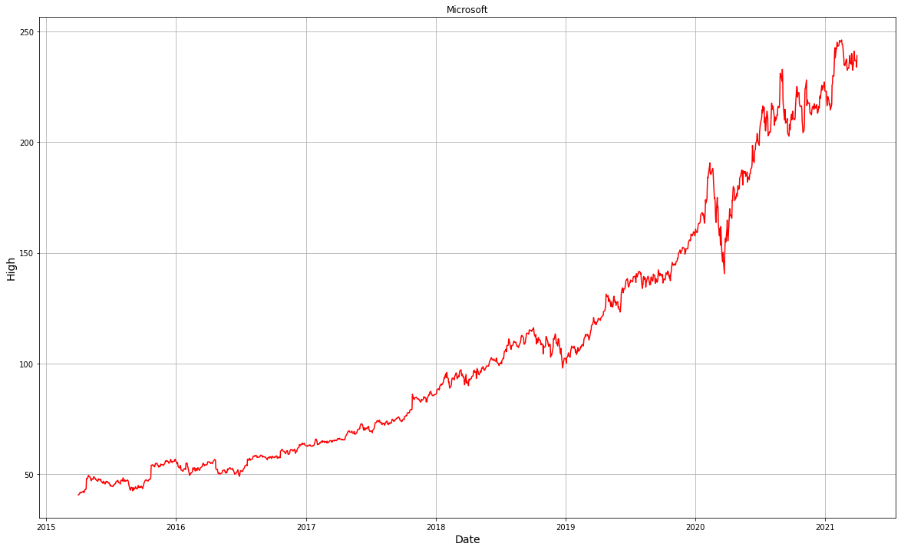

SECURITY TRADED(VOLUME) ACCORDING TO DATE
plt.figure(figsize=(20,12))
plt.plot(ms['Date'],ms['Volume'],color="mediumvioletred")
plt.title('Microsoft')
plt.xlabel('Year', fontsize=14)
plt.ylabel('Volume', fontsize=14)
plt.grid(which="major", color='k', linestyle='-.', linewidth=0.5)
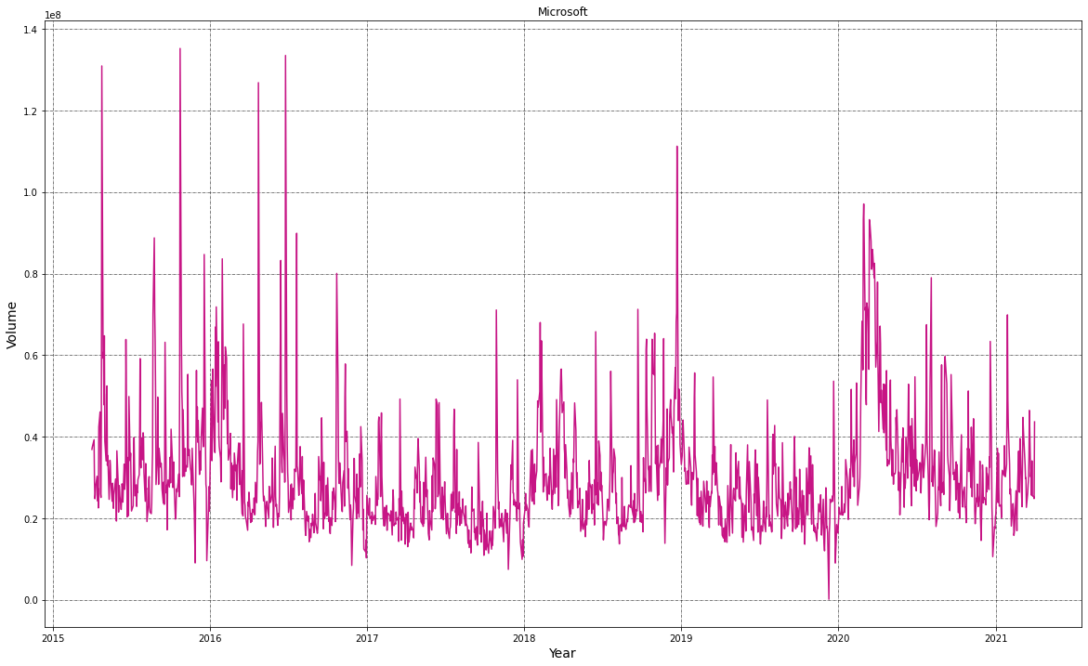

INITIAL QUANTITY OF STOCK
plt.figure(figsize=(20,12))
plt.plot(ms['Date'],ms['Open'],color='c')
plt.title('Microsoft')
plt.xlabel('Year', fontsize=14)
plt.ylabel('Open', fontsize=14)
plt.grid(which="major", color='k', linestyle='-.', linewidth=0.5)
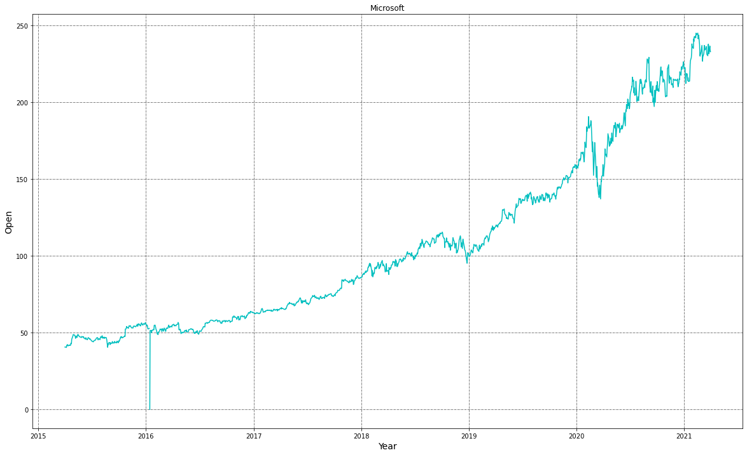

LOWEST PRICE OF STOCK ACCORDING TO DATE
plt.figure(figsize=(20,12))
plt.plot(ms['Date'],ms['Low'],color='navy')
plt.title('Microsoft')
plt.xlabel('Year', fontsize=14)
plt.ylabel('Low', fontsize=14)
plt.grid(which="major", color='k', linestyle='-.', linewidth=0.5)
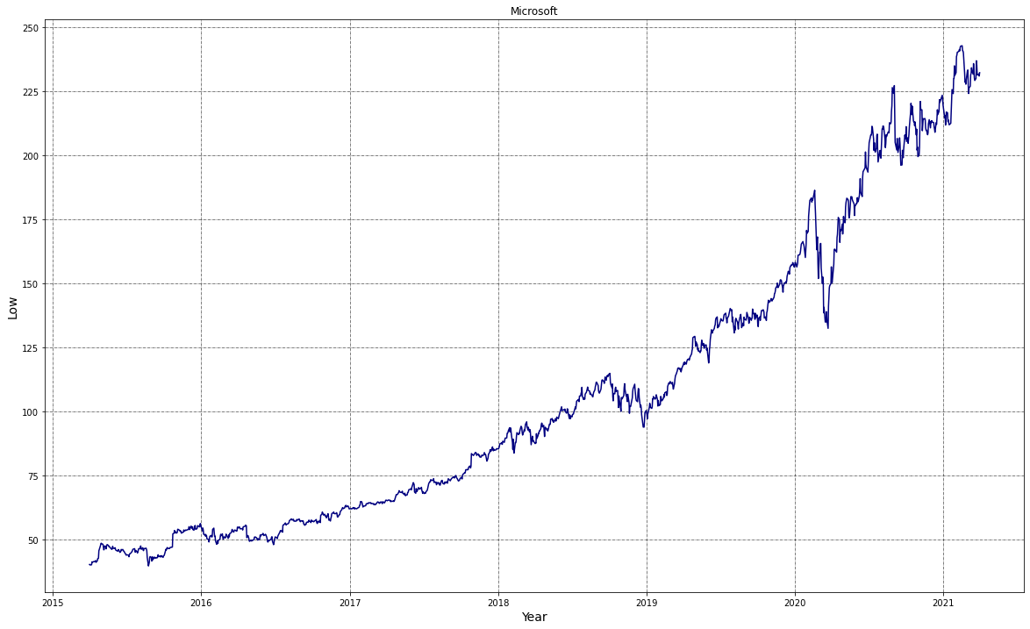

END OF TRADING SESSION ACCORDING TO DATE
plt.figure(figsize=(20,12))
plt.plot(ms['Date'],ms['Close'],color='lime')
plt.title('Microsoft')
plt.xlabel('Year', fontsize=14)
plt.ylabel('Close', fontsize=14)
plt.grid(which="major", color='k', linestyle='-.', linewidth=0.5)
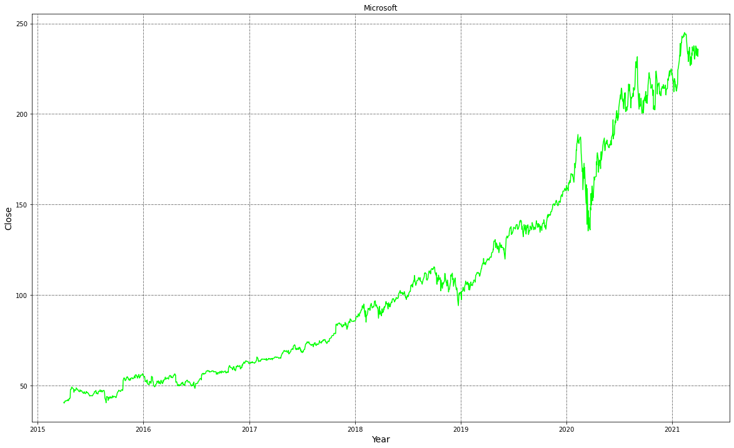

PERCENTAGE RETURN
ms['1day % return']=((ms['Close']-ms['Open'])/ms['Close'])*100
ms.head()
Date Open High Low Close Volume 1day % return
0 2015-04-01 16:00:00 40.60 40.76 40.31 40.72 36865322 0.294695
1 2015-04-02 16:00:00 40.66 40.74 40.12 40.29 37487476 -0.918342
2 2015-04-06 16:00:00 40.34 41.78 40.18 41.55 39223692 2.912154
3 2015-04-07 16:00:00 41.61 41.91 41.31 41.53 28809375 -0.192632
4 2015-04-08 16:00:00 41.48 41.69 41.04 41.42 24753438 -0.144858
ms.columns
Index(['Date', 'Open', 'High', 'Low', 'Close', 'Volume', '1day % return'], dtype='object')

ANALYSING MONTHLY MEAN OF CLOSE COLUMN
ms2=ms.copy()
ms2['date']=pd.to_datetime(ms2['Date'])
ms2.set_index('Date',inplace=True)
ms2.head()
Open High Low Close Volume 1day % return \
Date
2015-04-01 16:00:00 40.60 40.76 40.31 40.72 36865322 0.294695
2015-04-02 16:00:00 40.66 40.74 40.12 40.29 37487476 -0.918342
2015-04-06 16:00:00 40.34 41.78 40.18 41.55 39223692 2.912154
2015-04-07 16:00:00 41.61 41.91 41.31 41.53 28809375 -0.192632
2015-04-08 16:00:00 41.48 41.69 41.04 41.42 24753438 -0.144858
date
Date
2015-04-01 16:00:00 2015-04-01 16:00:00
2015-04-02 16:00:00 2015-04-02 16:00:00
2015-04-06 16:00:00 2015-04-06 16:00:00
2015-04-07 16:00:00 2015-04-07 16:00:00
2015-04-08 16:00:00 2015-04-08 16:00:00
ms2.describe()
Open High Low Close Volume \
count 1510.000000 1511.000000 1511.000000 1511.000000 1.511000e+03
mean 107.387689 108.437472 106.294533 107.422091 3.019863e+07
std 56.742016 57.382276 55.977155 56.702299 1.425266e+07
min 0.000000 40.740000 39.720000 40.290000 1.016120e+05
25% 57.872500 58.060000 57.420000 57.855000 2.136213e+07
50% 94.020000 95.100000 92.920000 93.860000 2.662962e+07
75% 139.440000 140.325000 137.825000 138.965000 3.431962e+07
max 245.030000 246.130000 242.920000 244.990000 1.352271e+08
1day % return
count 1510.000000
mean 0.102187
std 2.875063
min -6.297779
25% -0.573015
50% 0.068864
75% 0.741886
max 100.000000

Visualizing the multidimensional relationships among the samples is as easy as calling sns.pairplot:
sns.pairplot(data=ms2)
<seaborn.axisgrid.PairGrid at 0x1ae335e7850>
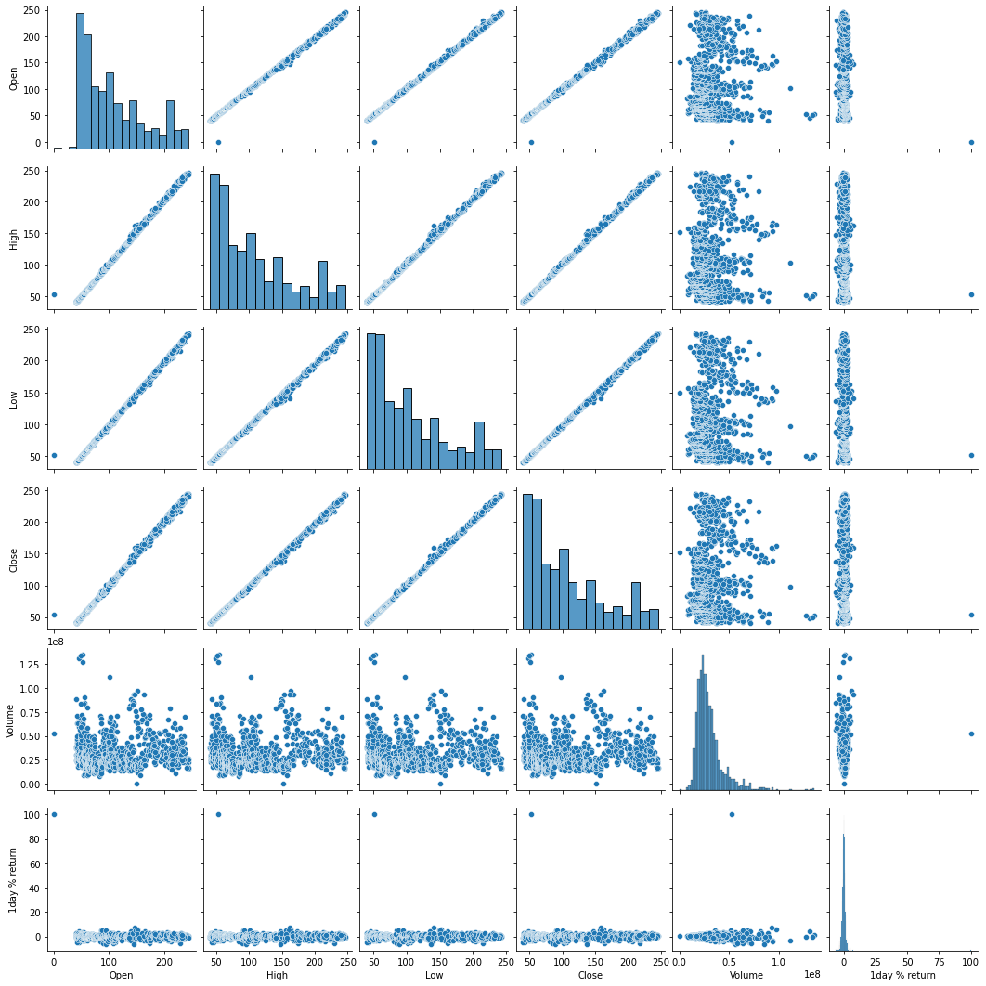
ms['ms_change']=((ms['Close']-ms['Open'])/ms['Close'])*100
ms.head()
Date Open High Low Close Volume 1day % return \
0 2015-04-01 16:00:00 40.60 40.76 40.31 40.72 36865322 0.294695
1 2015-04-02 16:00:00 40.66 40.74 40.12 40.29 37487476 -0.918342
2 2015-04-06 16:00:00 40.34 41.78 40.18 41.55 39223692 2.912154
3 2015-04-07 16:00:00 41.61 41.91 41.31 41.53 28809375 -0.192632
4 2015-04-08 16:00:00 41.48 41.69 41.04 41.42 24753438 -0.144858
ms_change
0 0.294695
1 -0.918342
2 2.912154
3 -0.192632
4 -0.144858

VALUE AT RISK ANALYSIS
sns.barplot(ms['ms_change'],color='#000')
C:\Users\admin\anaconda3\lib\site-packages\seaborn\_decorators.py:36: FutureWarning: Pass the following variable as a keyword arg: x. From version 0.12, the only valid positional argument will be `data`, and passing other arguments without an explicit keyword will result in an error or misinterpretation.
warnings.warn(
<AxesSubplot:xlabel='ms_change'>
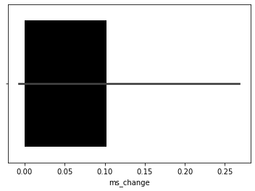
ms['ms_change'].std()
2.875063436933017
ms['ms_change'].quantile(0.1)
-1.349785836546177

STATICAL DETAILES USING DESCRIBE FUNCTION
ms.describe().T
count mean std min \
Open 1510.0 1.073877e+02 5.674202e+01 0.000000
High 1511.0 1.084375e+02 5.738228e+01 40.740000
Low 1511.0 1.062945e+02 5.597716e+01 39.720000
Close 1511.0 1.074221e+02 5.670230e+01 40.290000
Volume 1511.0 3.019863e+07 1.425266e+07 101612.000000
1day % return 1510.0 1.021866e-01 2.875063e+00 -6.297779
ms_change 1510.0 1.021866e-01 2.875063e+00 -6.297779
25% 50% 75% max
Open 5.787250e+01 9.402000e+01 1.394400e+02 2.450300e+02
High 5.806000e+01 9.510000e+01 1.403250e+02 2.461300e+02
Low 5.742000e+01 9.292000e+01 1.378250e+02 2.429200e+02
Close 5.785500e+01 9.386000e+01 1.389650e+02 2.449900e+02
Volume 2.136213e+07 2.662962e+07 3.431962e+07 1.352271e+08
1day % return -5.730148e-01 6.886357e-02 7.418856e-01 1.000000e+02
ms_change -5.730148e-01 6.886357e-02 7.418856e-01 1.000000e+02
plt.figure(figsize=(20,12))
plt.plot(ms['Date'],ms['1day % return'],color='magenta')
plt.title('Microsoft')
plt.xlabel('Year', fontsize=14)
plt.ylabel('1day % return', fontsize=14)
plt.grid(which="major", color='k', linestyle='-.', linewidth=0.5)
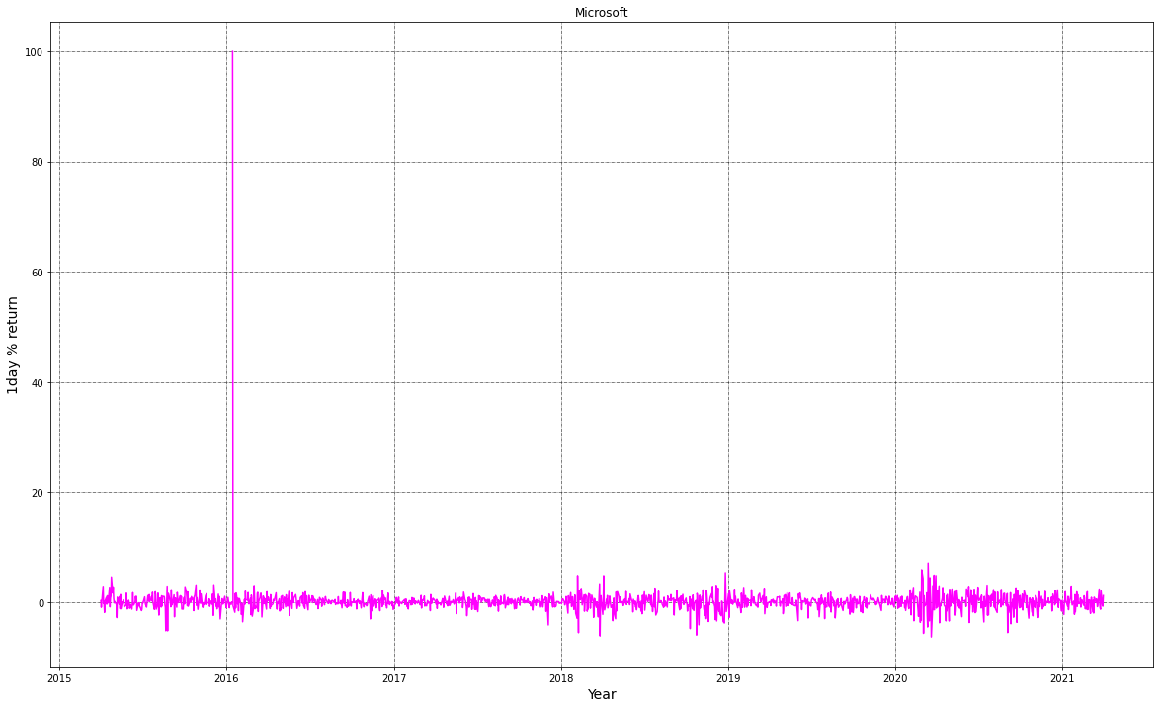
plt.figure(figsize=(20,12))
plt.plot(ms['Date'],ms['ms_change'],color='crimson')
plt.title('Microsoft')
plt.xlabel('Year', fontsize=14)
plt.ylabel('ms_change', fontsize=14)
plt.grid(which="major", color='k', linestyle='-.', linewidth=0.5)
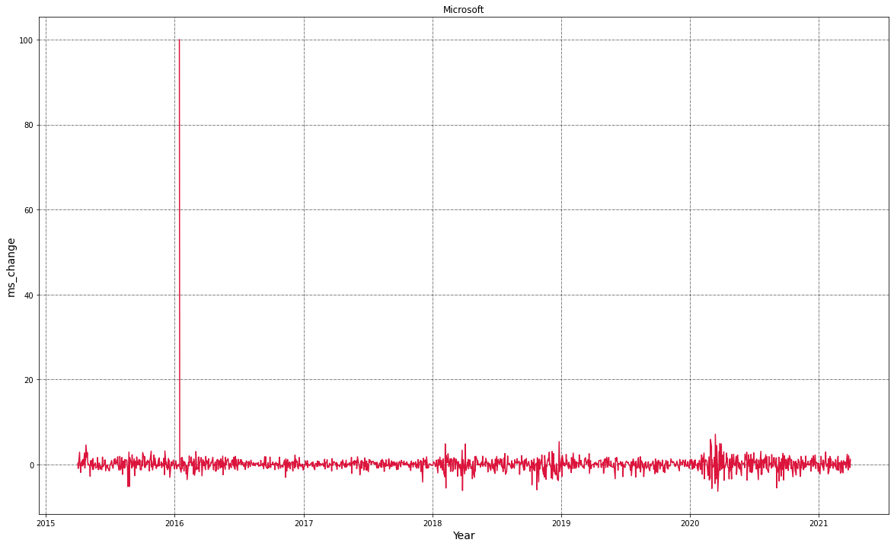

INITIAL QUANTITY WITH HIGH STOCK
plt.figure(figsize=(20,12))
sns.scatterplot(x='Open',y='High',data=ms,color='g')
<AxesSubplot:xlabel='Open', ylabel='High'>
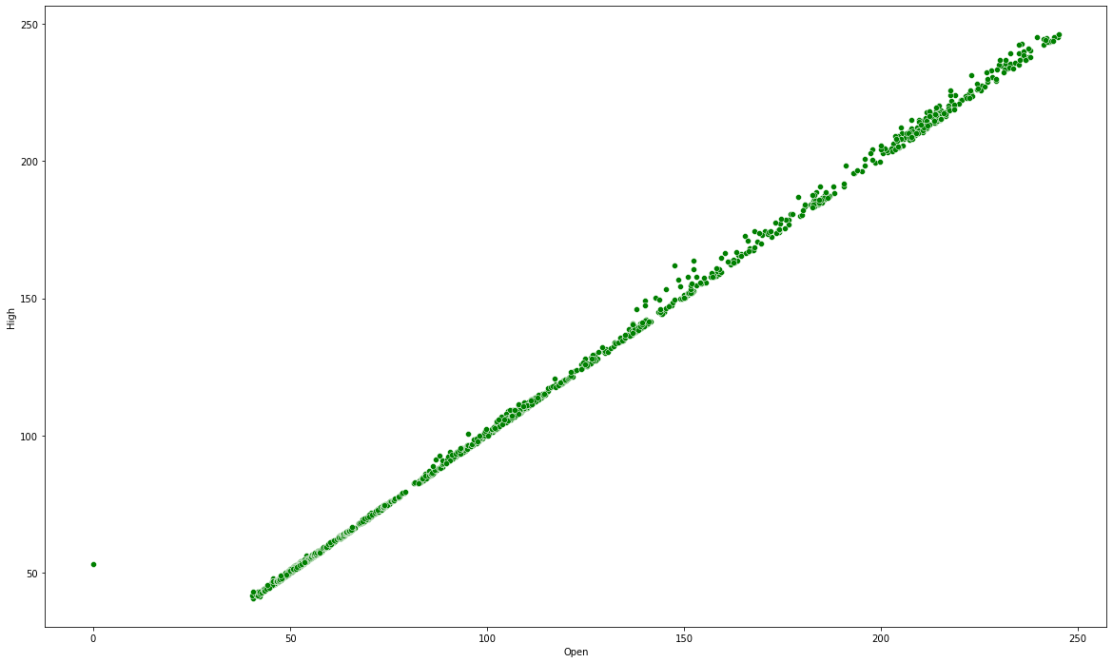

HIGH STOCK VALUE WITH DISTPLOT
sns.distplot(ms['High'],color='r')
C:\Users\admin\anaconda3\lib\site-packages\seaborn\distributions.py:2551: FutureWarning: `distplot` is a deprecated function and will be removed in a future version. Please adapt your code to use either `displot` (a figure-level function with similar flexibility) or `histplot` (an axes-level function for histograms).
warnings.warn(msg, FutureWarning)
<AxesSubplot:xlabel='High', ylabel='Density'>
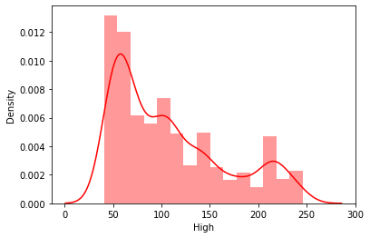

HIGH STOCK VALUE WITH DATE
sns.barplot(x='Date',y='High',data=ms)
<AxesSubplot:xlabel='Date', ylabel='High'>
